Supplementary material for: Malavenda S., Makarov M., Ryzhik I., Mityaev M. & Malavenda S. 2018. Occurrence of Ulva lactuca L. 1753 (Ulvaceae, Chlorophyta) on the Murman Coast of the Barents Sea. Polar Research 37. Contact: Malavenda Svetlana Vladimirovna, Murmansk Marine Biological Institute, Kola Scientific Center, Russian Academy of Sciences (MMBI KSC RAS), Vladimirskaya St. 17, 183010 Murmansk, Russia. E-mail: malavenda@yandex.ru.

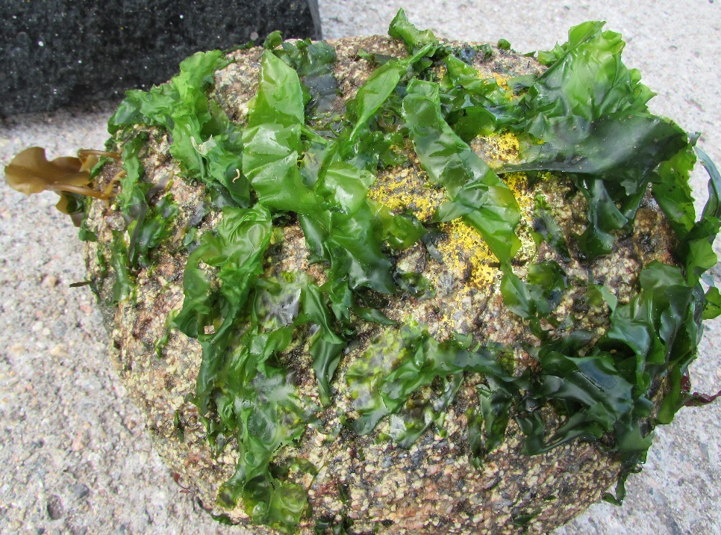
Supplementary Fig. S1. Boulder overgrown with thallus of Ulva lactuca, which is not typical for Murman algal communities.
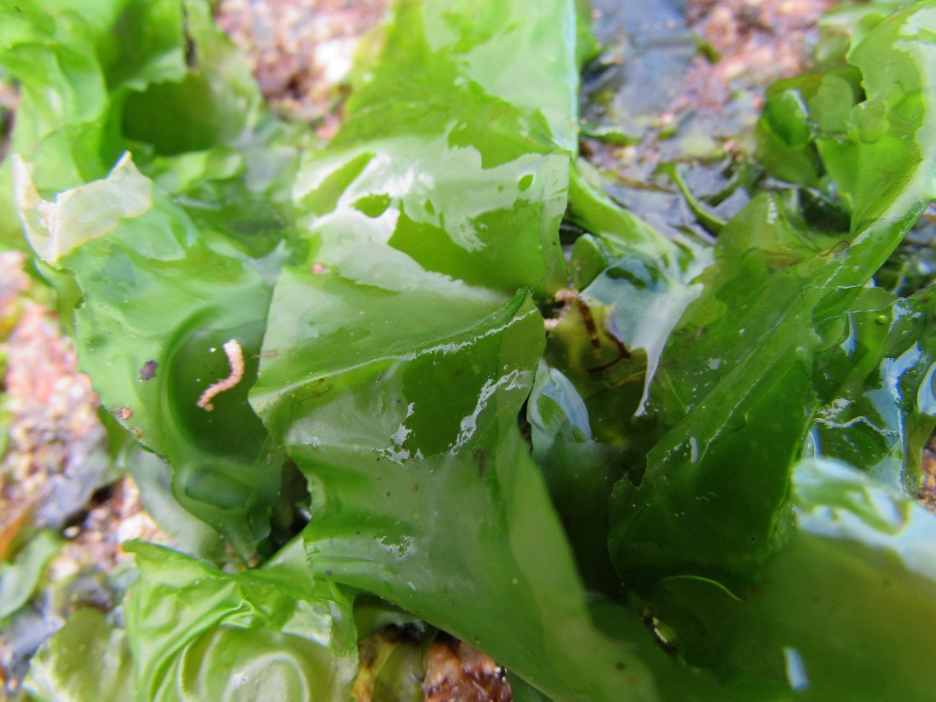
Supplementary Fig. S2. Typical form of thallus basis; thallus collected in 2017.

