Supplementary material for: Alexanderson H. & Landvik J.Y. 2018. Sediments of MIS 5e age suggested by new OSL dates from the Skilvika section, west Svalbard. Polar Research 37. Contact: Helena Alexanderson, Department of Geology, Lund University, Sölvegatan 12, 223 62 Lund, Sweden; helena.alexanderson@geol.lu.se
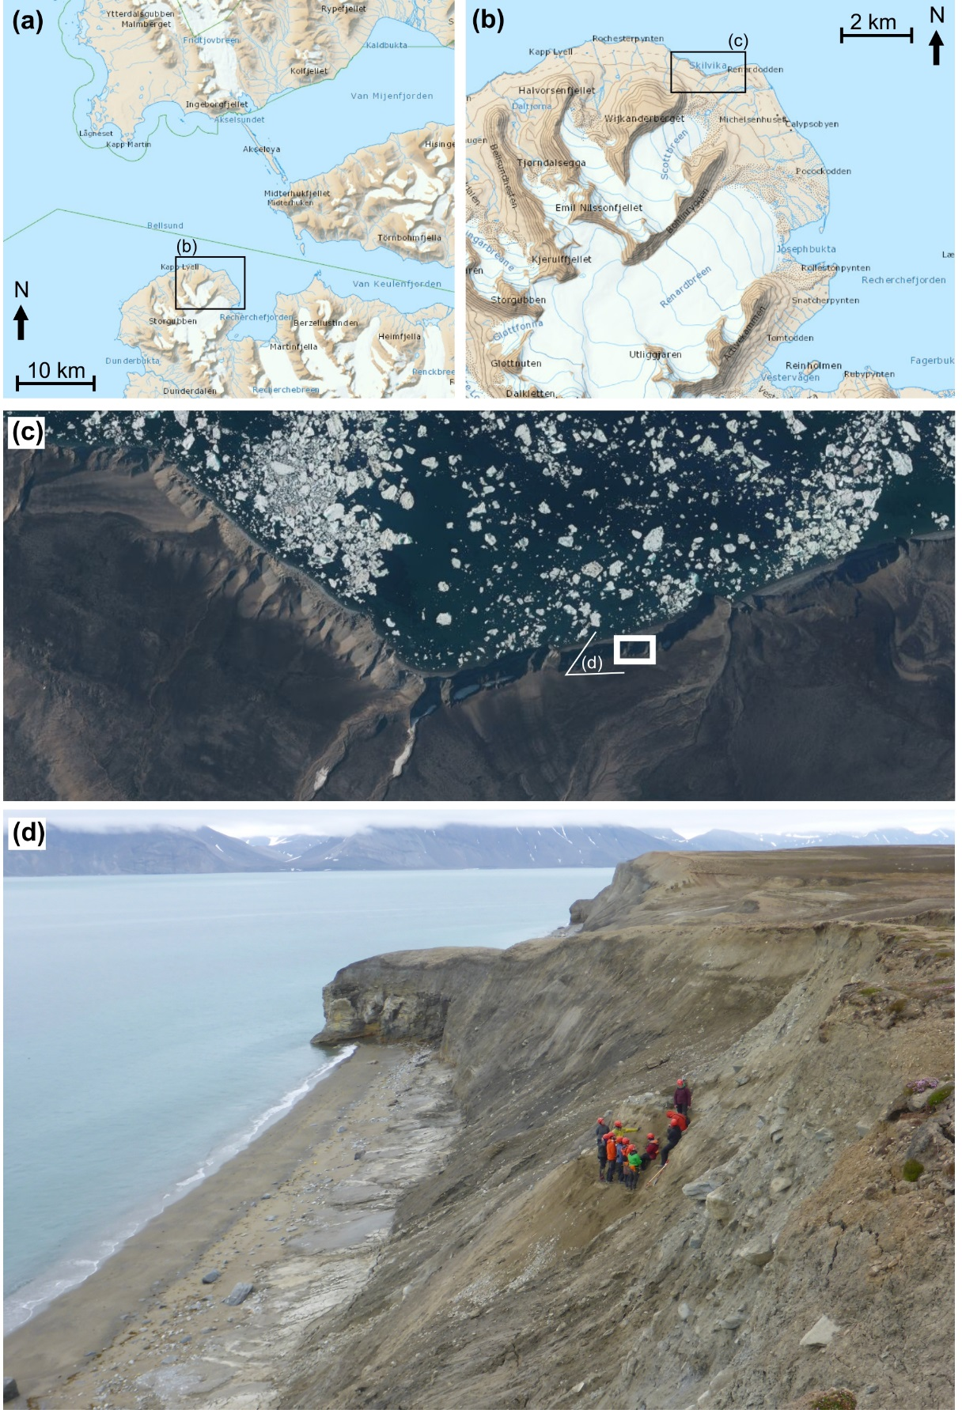
Supplementary Fig. S1. (a) and (b) Location maps of Bellsund and Skilvika, western Spitsbergen, excerpts from TopoSvalbard (© Norwegian Polar Institute). (c) Aerial photo from 2011 showing the Skilvika bay. The white rectangle indicates the location of the sampled section and the white open triangle the view of the photo in (d). (© Norwegian Polar Institute). (d) Photo towards the north-east of the coastal cliffs and the section investigated and sampled in 2015.

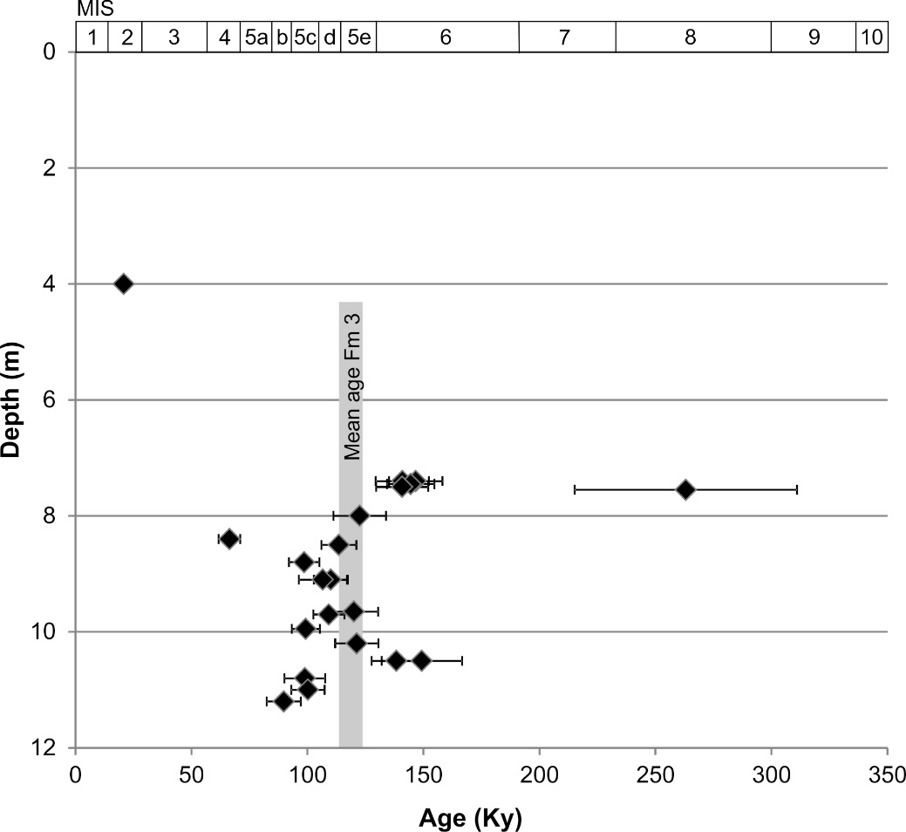
Supplementary Fig. S2. Plot of luminescence ages versus depth. The grey bar indicates the mean age (including error) of the Formation 3 ages (119 ± 5 Ky).

