Supplementary material for: Storrie L., Lydersen C., Andersen M., Wynn R.B. & Kovacs K.M. 2018. Determining the species assemblage and habitat use of cetaceans in the Svalbard Archipelago, based on observations from 2002 to 2014. Polar Research 37. Contact: Kit M. Kovacs, Norwegian Polar Institute, Fram Centre, PO Box 6606, Langnes, NO-9296 Tromsø, Norway. E-mail: kit.kovacs@npolar.no

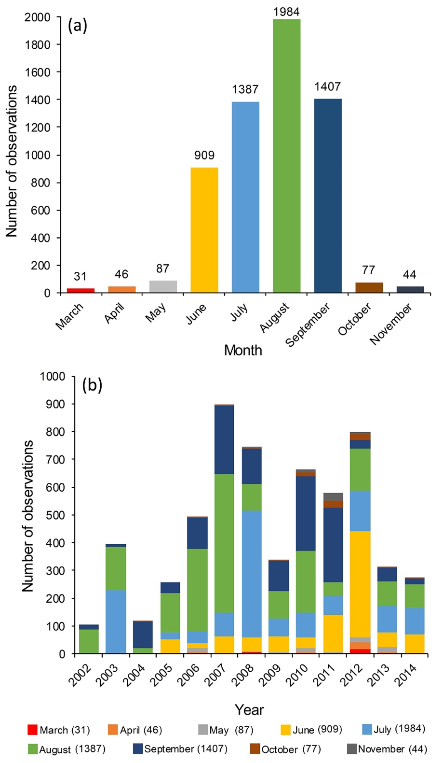
Supplementary Fig. S1. (a) Total number of observations for each month of the study period, and (b) total number of observations for each year of the study period, with proportion of observations by month.

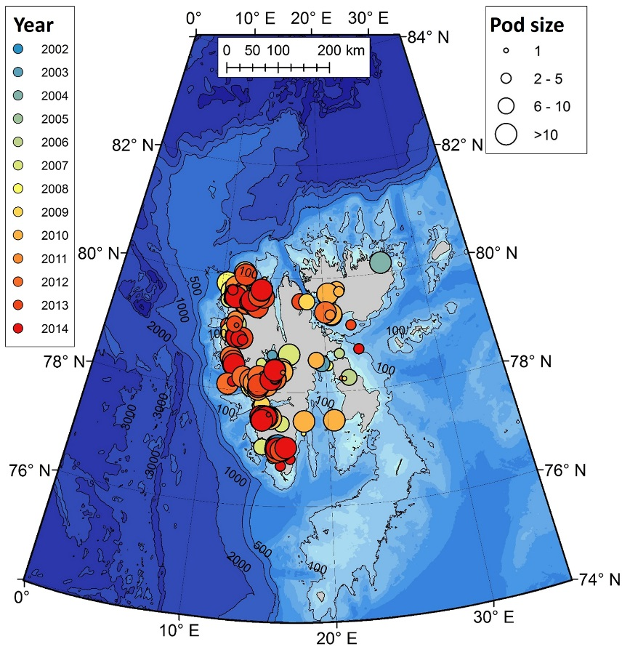

Supplementary Fig. S2. Observations of white whales. Colour gradient from blue to red represents year of observation from 2002 to 2014, and point size denotes pod size.

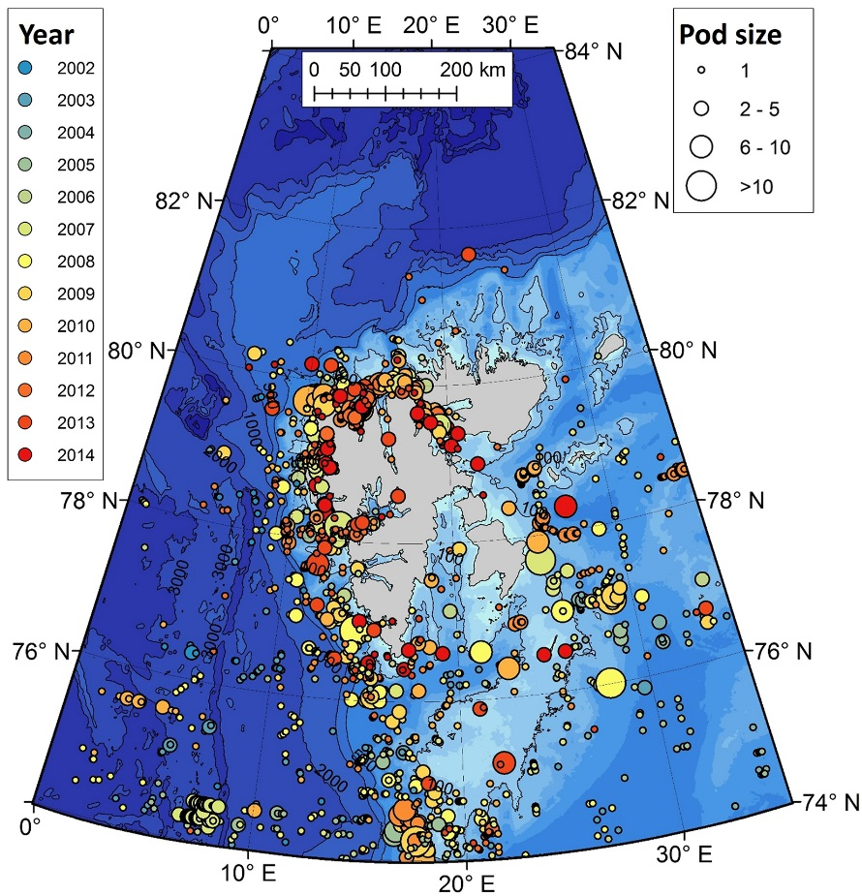

Supplementary Fig. S3. Observations of minke whales. Colour gradient from blue to red represents year of observation from 2002 to 2014, and point size denotes pod size.
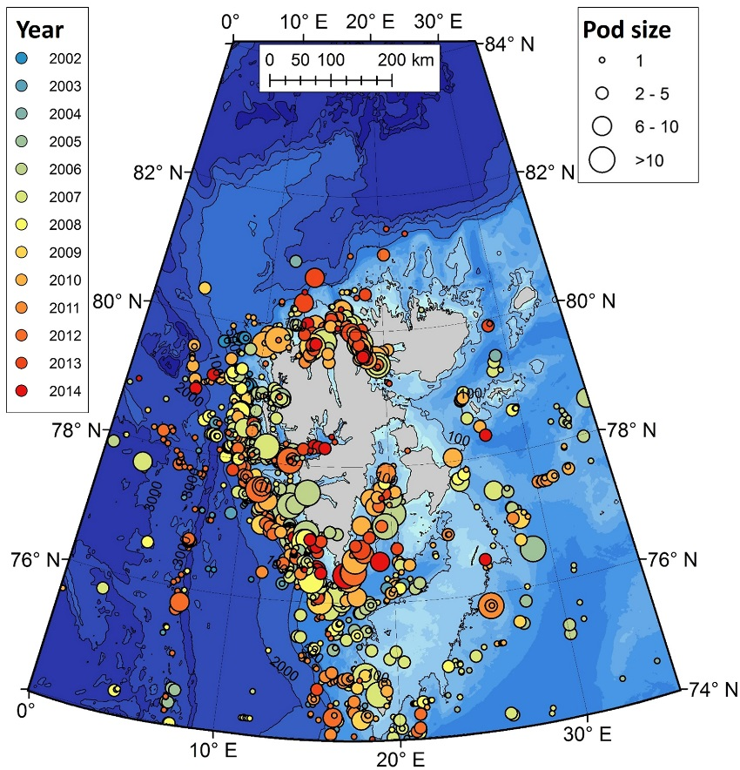

Supplementary Fig. S4. Observations of fin whales. Colour gradient from blue to red represents year of observation from 2002 to 2014, and point size denotes pod size.

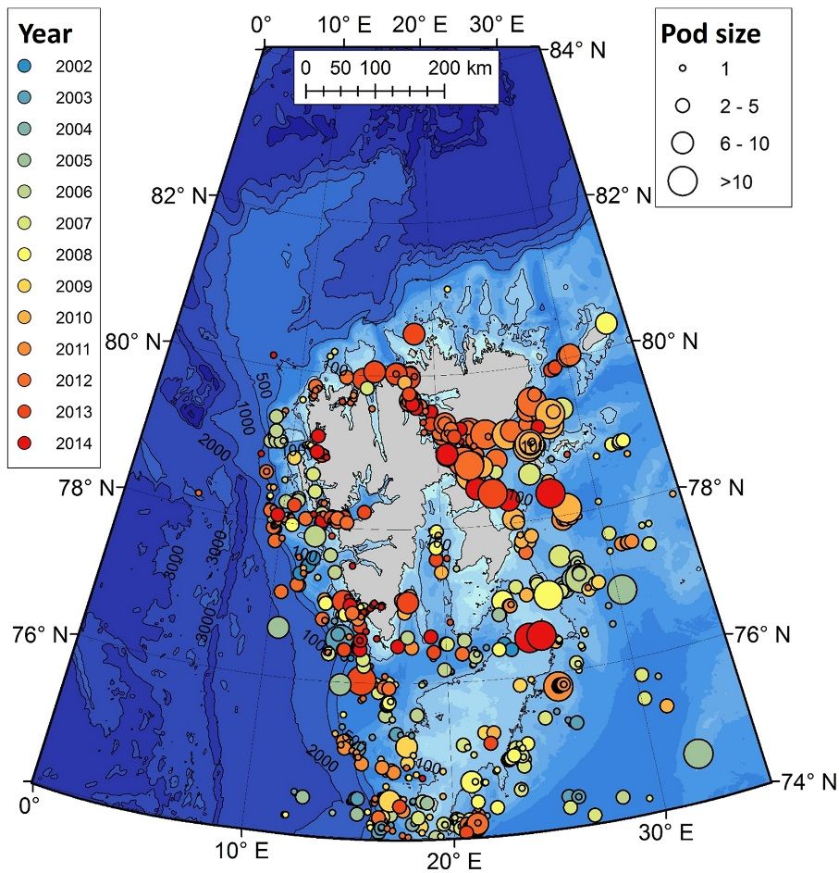

Supplementary Fig. S5. Observations of humpback whales. Colour gradient from blue to red represents year of observation from 2002 to 2014, and point size denotes pod size.
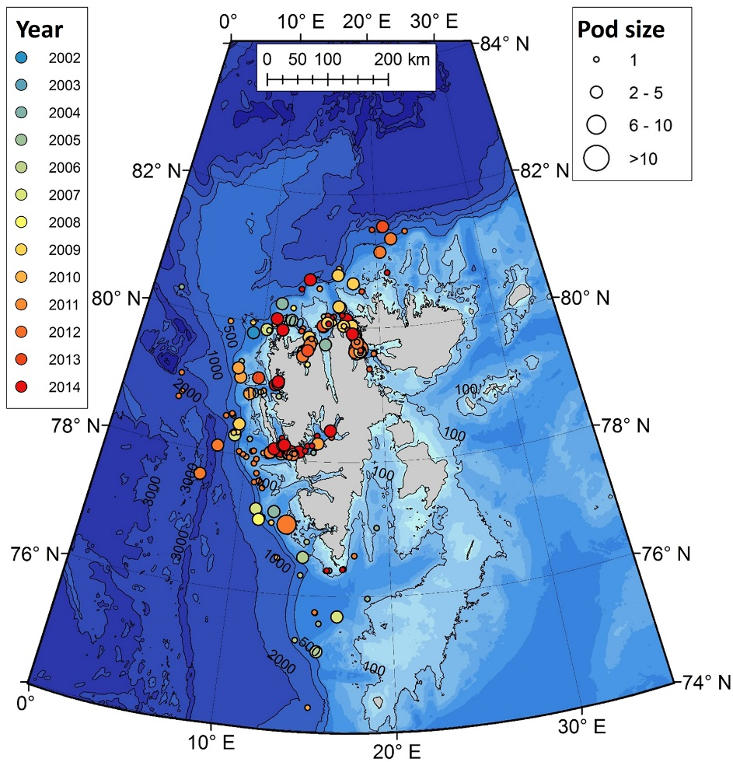

Supplementary Fig. S6. Observations of blue whales. Colour gradient from blue to red represents year of observation from 2002 to 2014, and point size denotes pod size.

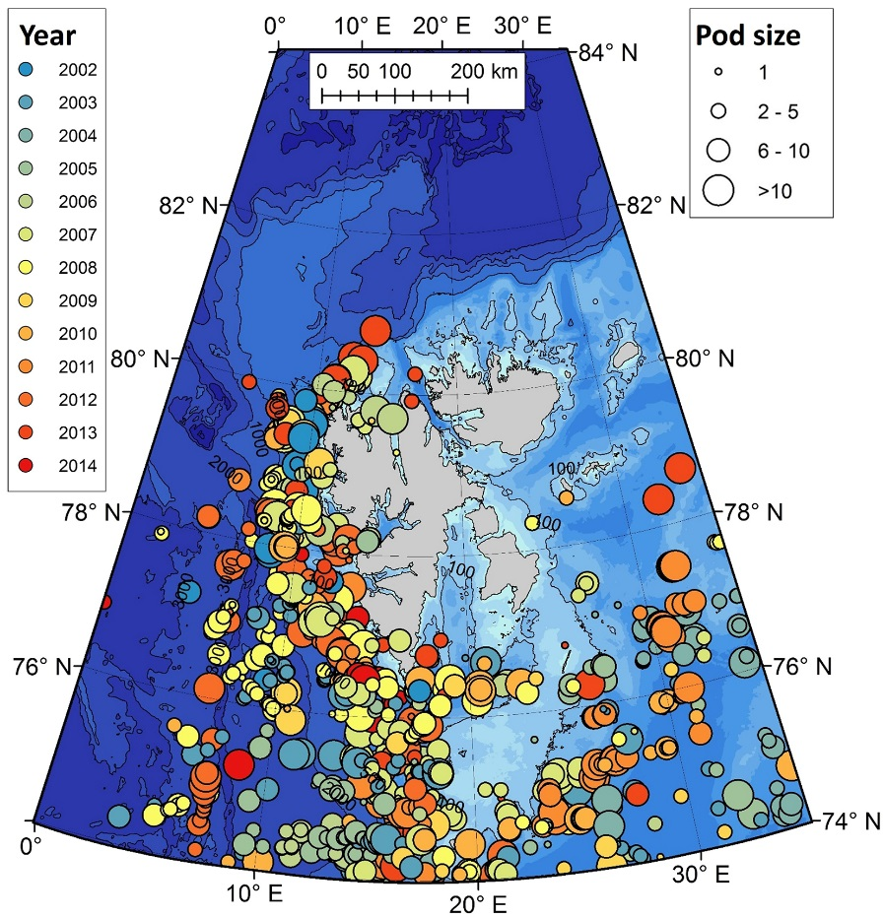

Supplementary Fig. S7. Observations of small dolphins (2 Lagenorhynchus spp. that occur in Svalbard). Colour gradient from blue to red represents year of observation from 2002-2014, and point size denotes pod size.
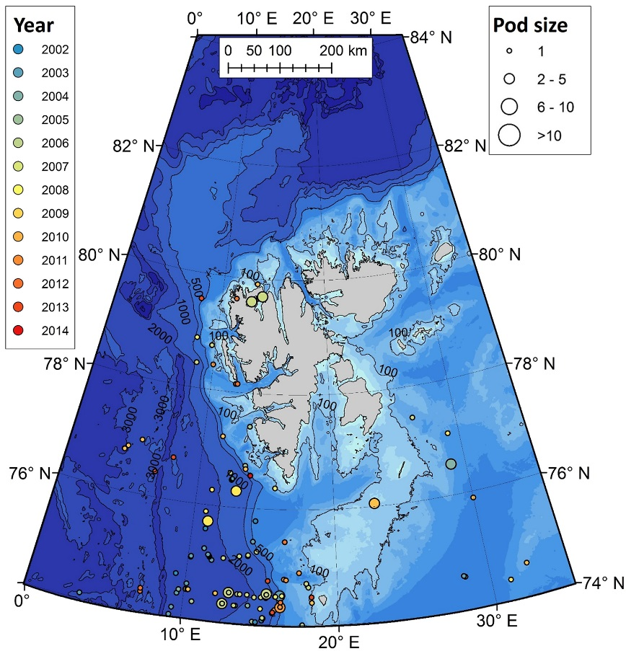

Supplementary Fig. S8. Observations of sperm whales. Colour gradient from blue to red represents year of observation from 2002 to 2014, and point size denotes pod size.

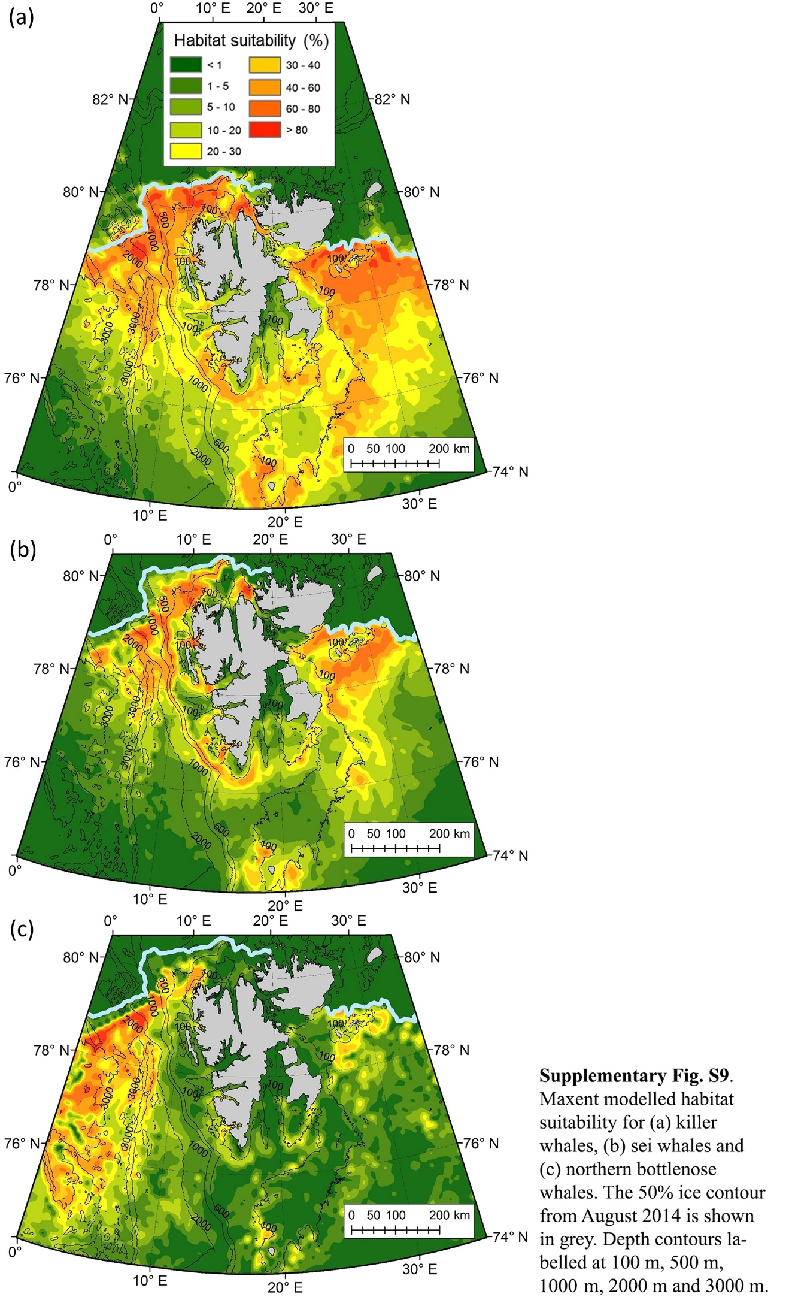
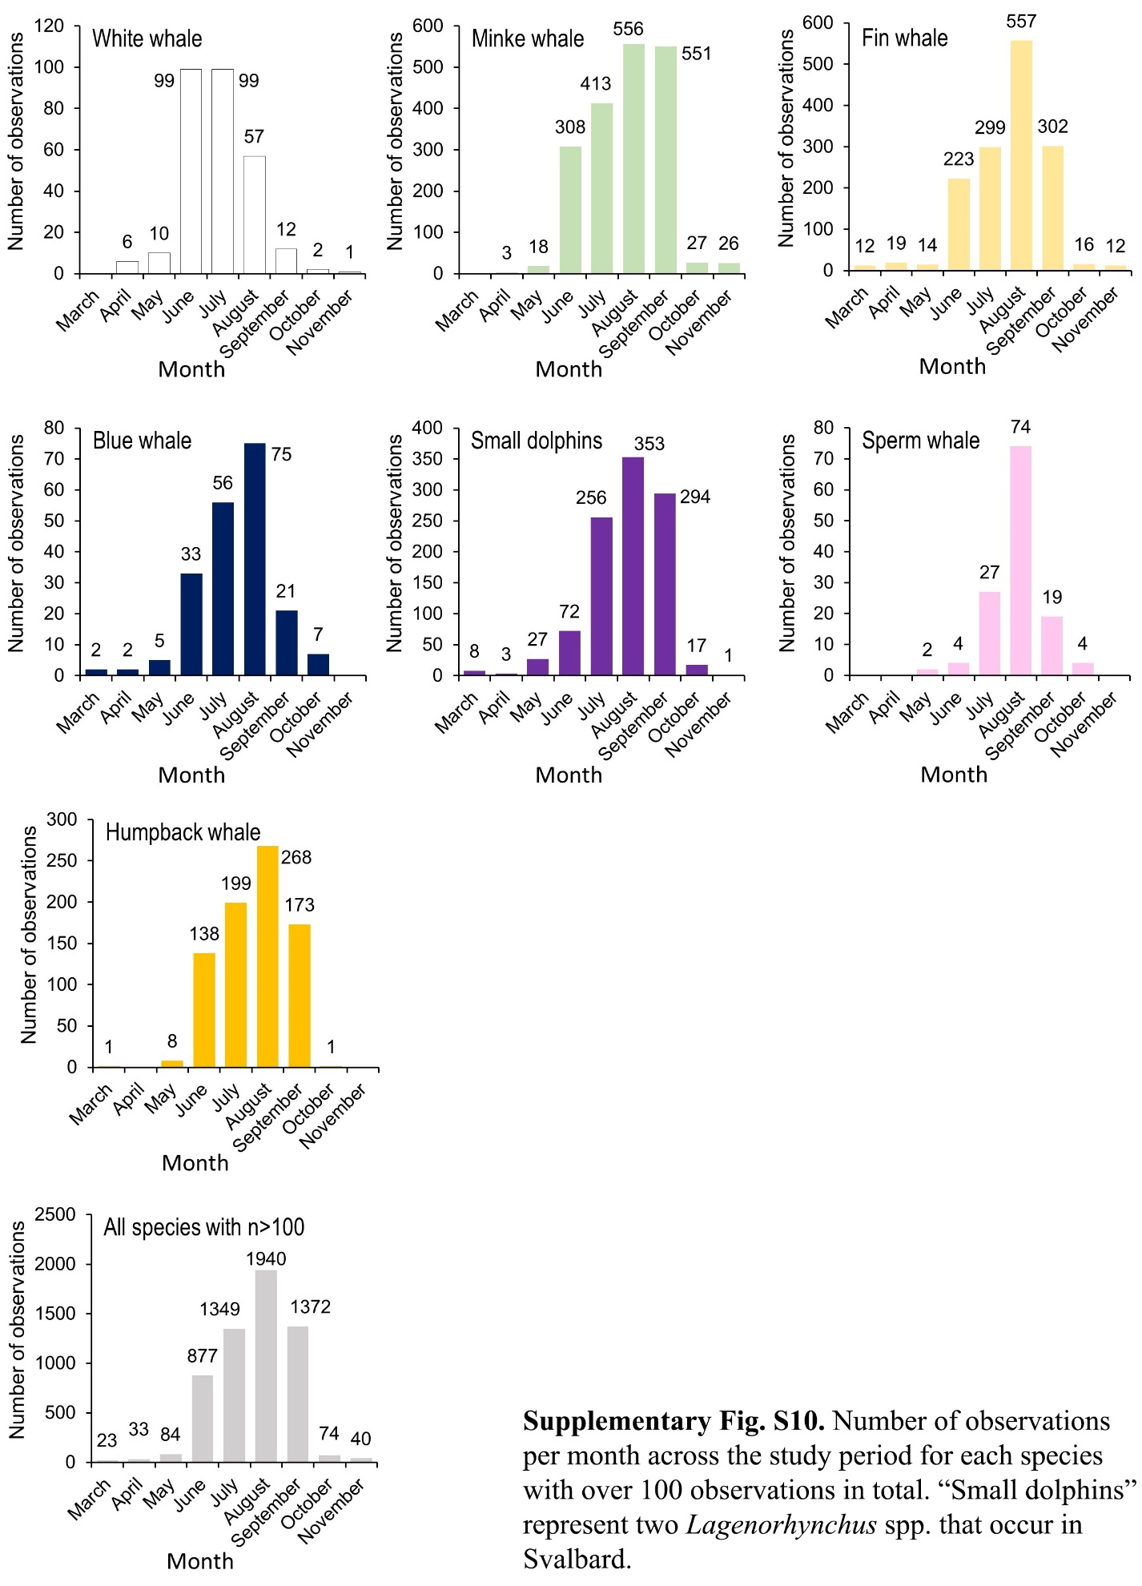

Supplementary Table S1. Maxent model performance exploring the contribution of the physical parameters – distance-to-coast, aspect, slope, depth, SST and ice cover – on cetacean habitat suitability models. The model outputs suggest a heavy reliance on the distance variable, with percentage contribution of this parameter being ≥27% for minke whale, fin whale, blue whale, humpback whale, small dolphins (Lagenorhynchus spp.), sei whale and killer whale models, and 77.6 % for the white whale model. Ice cover was also a critical model determinant for many species, contributing over 20% to the models for minke whales, fin whales, small dolphins, humpback whale, sperm whales, killer whales and northern bottlenose whales. The slope and SST parameters contributed minimally to the models of most species, except the northern bottlenose whale model, which relied more heavily on the slope (25.2%), SST (25.4%) and depth (18.9%) parameters than other species did. Aspect contributed very little to any of the models except that of the sperm whale (17.5%), in which all parameters played similar roles.

Species | Training AUC | No. observations  (model training) | Test AUC | No. observations (model testing) | Percentage contribution to model
 |  |  |  |  | Depth | Slope | Aspect | Distance | SST | Ice
Minke whale | 0.869 | 1210 | 0.867 | 518 | 3 | 11.6 | 0.4 | 42.3 | 12.6 | 30
Fin whale | 0.896 | 964 | 0.890 | 412 | 5.6 | 11.1 | 0.4 | 50.3 | 12.5 | 20.1
Small dolphins | 0.882 | 678 | 0.880 | 290 | 7.5 | 10.8 | 4.8 | 27 | 13 | 36.8
Humpback whale | 0.922 | 514 | 0.901 | 220 | 9.6 | 4.3 | 0.3 | 53.3 | 10.6 | 21.8
White whale | 0.984 | 189 | 0.978 | 80 | 0.4 | 14.5 | 1 | 77.6 | 3.3 | 3.2
Blue whale | 0.963 | 139 | 0.974 | 59 | 3.1 | 21.9 | 1.5 | 58.8 | 6.2 | 8.6
Sperm whale | 0.933 | 87 | 0.896 | 36 | 21.7 | 8.9 | 17.5 | 13.9 | 4.2 | 33.9
Killer whale | 0.937 | 28 | 0.906 | 11 | 7.2 | 6 | 1.1 | 31.9 | 22.3 | 31.6
Northern bottlenose whale | 0.969 | 26 | 0.95 | 11 | 18.9 | 25.2 | 0.4 | 2.2 | 25.4 | 27.9
Sei whale | 0.964 | 22 | 0.966 | 9 | 8.8 | 14.7 | 0.4 | 38.5 | 11.8 | 25.7

