Supplementary material for: Reisinger R.R., Landman M., Mgibantaka N., Smale M.J., Bester M.N., de Bruyn P.J.N. & Pistorius P.A. 2018. Overlap and temporal variation in the diets of sympatric Antarctic and Subantarctic fur seals (Arctocephalus spp.) at sub-Antarctic Marion Island. Polar Research 37. Contact: Ryan R. Reisinger, Centre d’Etudes Biologiques de Chizé, UMR 7372 du CNRS-Université de La Rochelle, 79360 Villiers-en-Bois, France, ryan.r.reisinger@gmail.com

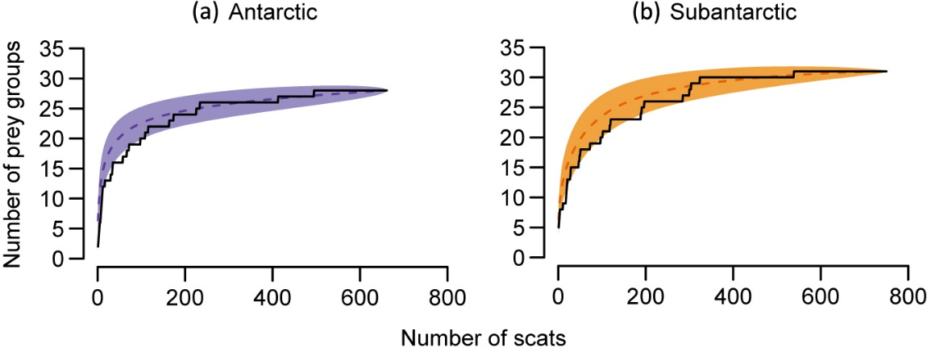

Supplementary Fig. S1. Species accumulation curves showing the cumulative number of prey groups identified against the number of scats collected, for (a) Antarctic and (b) Subantarctic fur seals. Solid black lines show the actual species accumulation curves, while dashed coloured lines show rarefaction estimates thereof, with 95% confidence intervals (shaded bands). The curves indicate that the number of scats was sufficient to identify most prey groups in the diet.

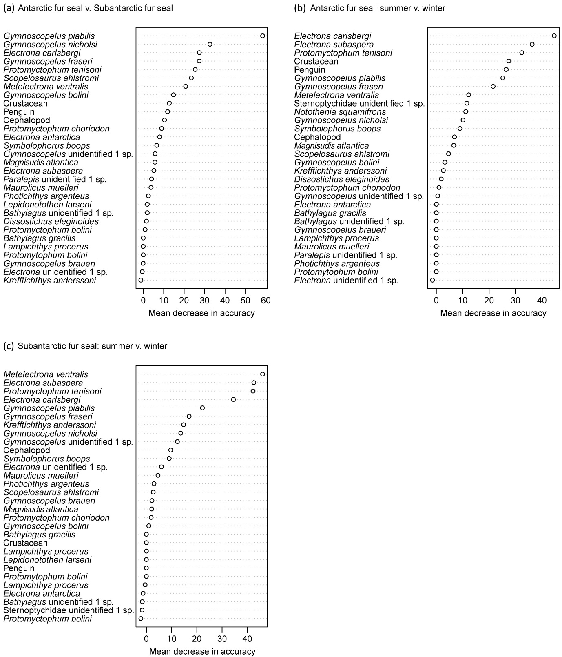

Supplementary Fig. S2. Relative variable importance (measured by mean decrease in accuracy) of prey species in random forest models distinguishing (a) Antarctic fur seal diet and Subantarctic fur seal diet; (b) Antarctic fur seal summer and winter diet; and (c) Subantarctic fur seal summer and winter diet. Higher values indicate more important variables.
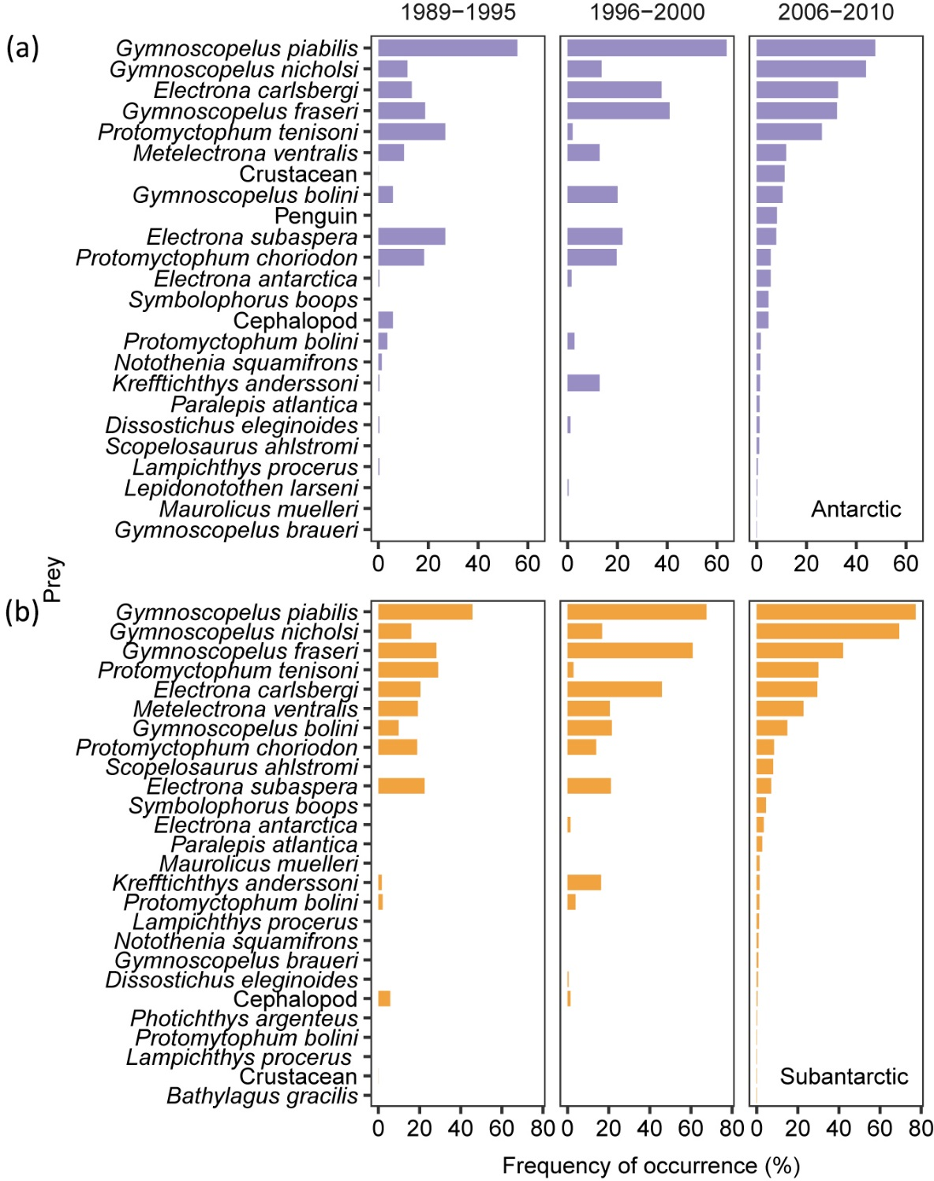

Supplementary Fig. S3. Frequency of occurrence (%) of (a) Antarctic and (b) Subantarctic fur seal prey during three study periods. Data are from Klages & Bester (1998): 1989-1995; Makhado et al. (2008, 2013): 1996-2000; and the present study: 2006-2010.
Supplementary Table S1. Prey remains found in the scats of (a) Antarctic (Arctocephalus gazella) and (b) Subantarctic (A. tropicalis) fur seals, collected at Marion Island from April 2006 to March 2010.

Prey | Fª |  |  | %F^{b} |  |  | N^{c} |  |  | %N^{d} |  |  | Rank^{e}
 | F | LCL | UCL | %F | LCL | UCL | N | LCL | UCL | %N | LCL | UCL | %F | %N
(a)
Cephalopod | 31 | 21 | 42 | 4.7 | 3.2 | 6.4 | 33 | 22 | 46 | 0.4 | 0.2 | 0.5 | 14 | 15
Crustacean | 74 | 57 | 90 | 11.2 | 8.6 | 13.6 | 75 | 58 | 92 | 0.8 | 0.6 | 1.1 | 7 | 11
Penguin | 54 | 40 | 68 | 8.2 | 6.1 | 10.3 | 54 | 40 | 68 | 0.6 | 0.4 | 0.8 | 9 | 13
Fish^{e} | 502 | 479 | 523 | 75.9 | 72.5 | 79.1 | 8899 | 7936 | 9971 | 98.2 | 97.8 | 98.5
Bathylagidae
Bathylagus unidentified 1 sp. | 1 | 0 | 3 | 0.2 | 0.0 | 0.5 | 1 | 0 | 3 | 0.0 | 0.0 | 0.0 | 28 | 27
Nototheniidae
Dissostichus eleginoides | 8 | 3 | 14 | 1.2 | 0.5 | 2.1 | 16 | 6 | 31 | 0.2 | 0.1 | 0.3 | 19 | 17
Lepidonotothen larseni | 2 | 0 | 5 | 0.3 | 0.0 | 0.8 | 3 | 0 | 8 | 0.0 | 0.0 | 0.1 | 25 | 24
Notothenia squamifrons | 10 | 4 | 16 | 1.5 | 0.6 | 2.4 | 49 | 12 | 100 | 0.5 | 0.1 | 1.1 | 17 | 14
Myctophidae
Electrona antarctica | 37 | 26 | 49 | 5.6 | 3.9 | 7.4 | 129 | 58 | 235 | 1.4 | 0.7 | 2.6 | 11 | 9
Electrona carlsbergi | 216 | 193 | 241 | 32.7 | 29.2 | 36.5 | 879 | 713 | 1067 | 9.7 | 7.9 | 11.8 | 3 | 5
Electrona unidentified 1 sp. | 2 | 0 | 5 | 0.3 | 0.0 | 0.8 | 2 | 0 | 5 | 0.0 | 0.0 | 0.1 | 24 | 25
Electrona subaspera | 52 | 38 | 66 | 7.9 | 5.8 | 10 | 249 | 162 | 370 | 2.7 | 1.8 | 4.1 | 10 | 7
Gymnoscopelus bolini | 69 | 53 | 85 | 10.4 | 8.0 | 12.9 | 183 | 131 | 241 | 2.0 | 1.5 | 2.6 | 8 | 8
Gymnoscopelus braueri | 1 | 0 | 3 | 0.2 | 0.0 | 0.5 | 1 | 0 | 3 | 0.0 | 0.0 | 0.0 | 26 | 28
Gymnoscopelus fraseri | 213 | 188 | 236 | 32.2 | 28.4 | 35.7 | 1198 | 969 | 1441 | 13.2 | 11.1 | 15.5 | 4 | 4
Gymnoscopelus nicholsi | 290 | 266 | 316 | 43.9 | 40.2 | 47.8 | 1550 | 1302 | 1820 | 17.1 | 14.9 | 19.5 | 2 | 3
Gymnoscopelus piabilis | 315 | 288 | 340 | 47.7 | 43.6 | 51.4 | 2349 | 1931 | 2849 | 25.9 | 22.5 | 29.3 | 1 | 1
Gymnoscopelus unidentified 1 sp. | 12 | 6 | 19 | 1.8 | 0.9 | 2.9 | 20 | 8 | 36 | 0.2 | 0.1 | 0.4 | 15 | 16
Krefftichthys anderssoni | 9 | 4 | 15 | 1.4 | 0.6 | 2.3 | 15 | 5 | 27 | 0.2 | 0.1 | 0.3 | 18 | 19
Lampichthys procerus | 3 | 0 | 7 | 0.5 | 0.0 | 1.1 | 4 | 0 | 10 | 0.0 | 0.0 | 0.1 | 22 | 23
Metelectrona ventralis | 78 | 62 | 94 | 11.8 | 9.4 | 14.2 | 308 | 202 | 434 | 3.4 | 2.3 | 4.6 | 6 | 6
Protomyctophum bolini | 11 | 5 | 18 | 1.7 | 0.8 | 2.7 | 16 | 7 | 27 | 0.2 | 0.1 | 0.3 | 16 | 18
Protomyctophum choriodon | 37 | 26 | 49 | 5.6 | 3.9 | 7.4 | 115 | 59 | 198 | 1.3 | 0.7 | 2.2 | 12 | 10
Protomyctophum tenisoni | 173 | 151 | 195 | 26.2 | 22.8 | 29.5 | 1714 | 1235 | 2284 | 18.9 | 14.3 | 24 | 5 | 2
Symbolophorus boops | 31 | 21 | 42 | 4.7 | 3.2 | 6.4 | 69 | 40 | 105 | 0.8 | 0.5 | 1.1 | 13 | 12
Sternoptychidae
Maurolicus muelleri | 1 | 0 | 3 | 0.2 | 0.0 | 0.5 | 1 | 0 | 3 | 0.0 | 0.0 | 0.0 | 27 | 26
Sternoptychidae unidentified 1 sp. | 3 | 0 | 7 | 0.5 | 0.0 | 1.1 | 5 | 0 | 13 | 0.1 | 0.0 | 0.1 | 23 | 22
Paralepididae
Magnisudis atlantica | 8 | 3 | 14 | 1.2 | 0.5 | 2.1 | 11 | 4 | 20 | 0.1 | 0.0 | 0.2 | 20 | 21
Notosudidae
Scopelosaurus ahlstromi | 7 | 2 | 12 | 1.1 | 0.3 | 1.8 | 12 | 3 | 22 | 0.1 | 0.0 | 0.2 | 21 | 20

(b)
Cephalopod | 3 | 0 | 7 | 0.4 | 0.0 | 0.9 | 3 | 0 | 7 | 0.0 | 0.0 | 0.1 | 25 | 26
Crustacean | 1 | 0 | 4 | 0.1 | 0.0 | 0.5 | 1 | 0 | 4 | 0.0 | 0.0 | 0.0 | 30 | 30
Fish^{e} | 746 | 741 | 749 | 99.5 | 98.8 | 99.9 | 13650 | 12589 | 14628 | 100.0 | 99.9 | 100.0
Bathylagidae
Bathylagus gracilis | 1 | 0 | 3 | 0.1 | 0.0 | 0.4 | 2 | 0 | 6 | 0.0 | 0.0 | 0.0 | 28 | 29
Bathylagus unidentified 1 sp. | 5 | 1 | 10 | 0.7 | 0.1 | 1.3 | 5 | 1 | 10 | 0.0 | 0.0 | 0.1 | 24 | 25
Nototheniidae
Dissostichus eleginoides | 5 | 1 | 10 | 0.7 | 0.1 | 1.3 | 7 | 1 | 14 | 0.1 | 0.0 | 0.1 | 22 | 23
Notothenia squamifrons | 7 | 2 | 12 | 0.9 | 0.3 | 1.6 | 11 | 3 | 20 | 0.1 | 0.0 | 0.1 | 20 | 19
Myctophidae
Electrona antarctica | 26 | 16 | 36 | 3.5 | 2.1 | 4.8 | 41 | 25 | 61 | 0.3 | 0.2 | 0.4 | 12 | 12
Electrona carlsbergi | 221 | 199 | 246 | 29.5 | 26.5 | 32.8 | 643 | 540 | 769 | 4.7 | 4.0 | 5.5 | 5 | 6
Electrona unidentified 1 sp. | 2 | 0 | 5 | 0.3 | 0.0 | 0.7 | 2 | 0 | 5 | 0.0 | 0.0 | 0.0 | 26 | 28
Electrona subaspera | 53 | 41 | 67 | 7.1 | 5.5 | 8.9 | 164 | 100 | 243 | 1.2 | 0.7 | 1.8 | 10 | 9
Gymnoscopelus bolini | 112 | 93 | 132 | 14.9 | 12.4 | 17.6 | 230 | 179 | 286 | 1.7 | 1.3 | 2.1 | 7 | 7
Gymnoscopelus braueri | 6 | 2 | 11 | 0.8 | 0.3 | 1.5 | 10 | 2 | 21 | 0.1 | 0.0 | 0.2 | 21 | 21
Gymnoscopelus fraseri | 315 | 288 | 342 | 42.0 | 38.4 | 45.6 | 2301 | 1909 | 2758 | 16.9 | 14.1 | 19.9 | 3 | 4
Gymnoscopelus nicholsi | 520 | 497 | 545 | 69.3 | 66.3 | 72.7 | 2900 | 2604 | 3238 | 21.2 | 19.4 | 23.3 | 2 | 2
Gymnoscopelus piabilis | 580 | 558 | 602 | 77.3 | 74.4 | 80.3 | 3573 | 3270 | 3897 | 26.2 | 23.9 | 28.4 | 1 | 1
Gymnoscopelus unidentified 1 sp. | 11 | 5 | 18 | 1.5 | 0.7 | 2.4 | 19 | 9 | 32 | 0.1 | 0.1 | 0.2 | 16 | 14
Krefftichthys anderssoni | 11 | 5 | 18 | 1.5 | 0.7 | 2.4 | 15 | 6 | 27 | 0.1 | 0.0 | 0.2 | 14 | 16
Lampichthys procerus | 10 | 4 | 15 | 1.3 | 0.5 | 2.0 | 14 | 5 | 21 | 0.1 | 0.0 | 0.2 | 18 | 18
Metelectrona ventralis | 171 | 150 | 195 | 22.8 | 20.0 | 26.0 | 990 | 723 | 1333 | 7.3 | 5.3 | 9.5 | 6 | 5
Protomyctophum bolini | 10 | 4 | 17 | 1.3 | 0.5 | 2.3 | 18 | 6 | 34 | 0.1 | 0.0 | 0.3 | 17 | 15
Protomyctophum choriodon | 63 | 49 | 77 | 8.4 | 6.5 | 10.3 | 167 | 101 | 248 | 1.2 | 0.7 | 1.8 | 8 | 8
Protomyctophum tenisoni | 225 | 200 | 249 | 30.0 | 26.7 | 33.2 | 2326 | 1876 | 2852 | 17.0 | 13.9 | 20.3 | 4 | 3
Protomytophum bolini | 1 | 0 | 3 | 0.1 | 0.0 | 0.4 | 8 | 0 | 24 | 0.1 | 0.0 | 0.2 | 29 | 22
Symbolophorus boops | 34 | 23 | 44 | 4.5 | 3.1 | 5.9 | 62 | 40 | 85 | 0.5 | 0.3 | 0.6 | 11 | 11
Sternoptychidae
Maurolicus muelleri | 11 | 5 | 18 | 1.5 | 0.7 | 2.4 | 12 | 5 | 20 | 0.1 | 0 | 0.2 | 15 | 17
Sternoptychidae unidentified 1 sp. | 8 | 3 | 14 | 1.1 | 0.4 | 1.9 | 10 | 3 | 18 | 0.1 | 0 | 0.1 | 19 | 20
Paralepididae
Magnisudis atlantica | 20 | 12 | 29 | 2.7 | 1.6 | 3.9 | 25 | 14 | 37 | 0.2 | 0.1 | 0.3 | 13 | 13
Paralepis unidentified 1 sp. | 5 | 1 | 10 | 0.7 | 0.1 | 1.3 | 6 | 1 | 12 | 0.0 | 0.0 | 0.1 | 23 | 24
Phosichthyidae
Photichthys argenteus | 2 | 0 | 5 | 0.3 | 0.0 | 0.7 | 2 | 0 | 5 | 0.0 | 0.0 | 0.0 | 27 | 27
Notosudidae
Scopelosaurus ahlstromi | 60 | 46 | 76 | 8.0 | 6.1 | 10.1 | 87 | 65 | 113 | 0.6 | 0.5 | 0.8 | 9 | 10
ª Percentage frequency occurrence. ^{b} Percentage numerical abundance. ^{c} Lower 95% confidence limit. ^{d} Upper 95% confidence limit. ^{e} Values shown here for fishes were calculated by pooling all fish prey together.
Supplementary Table S2. Changes in prey %N in the summer diet of Antarctic and Subantarctic fur seals at Marion Island. The table shows parameters from linear regressions of %N against year. Correlation is Pearson’s correlation between %N values for each prey item in the two species over three summers.

Prey | Antarctic fur seal |  |  |  | Subantarctic fur seal |  |  |  | Correla-tion
 | Slope | SD | t | p | Slope | SD | t | p
Cephalopod | 0.11 | 0.09 | 1.15 | 0.370 | 0.06 | 0.03 | 1.73 | 0.333 | 0.68
Crustacean | 0.82 | 0.30 | 2.71 | 0.114
Penguin | 0.89 | 0.23 | 3.88 | 0.061
Fishes
Bathylagus gracilis |  |  |  |  | -0.03 | 0.02 | -1.73 | 0.333
Dissostichus eleginoides | 0.15 | 0.14 | 1.07 | 0.398 | 0.06 | 0.05 | 1.15 | 0.454 | 0.87
Electrona antarctica | -0.61 | 0.21 | -2.83 | 0.105 | 0.13 | 0.10 | 1.37 | 0.401 | -0.30
Electrona carlsbergi | -0.37 | 0.33 | -1.12 | 0.379 | 0.71 | 0.31 | 2.28 | 0.263 | 0.86
Electrona subaspera | 0.05 | 0.21 | 0.26 | 0.822 | 0.30 | 0.26 | 1.19 | 0.445 | -0.88
Gymnoscopelus bolini | -0.74 | 0.26 | -2.82 | 0.106 | -0.43 | 0.14 | -3.04 | 0.202 | 1.00
Gymnoscopelus braueri |  |  |  |  | -0.15 | 0.09 | -1.73 | 0.333 | 0.99
Gymnoscopelus fraseri | -4.06 | 1.02 | -3.98 | 0.058 | -10.55 | 4.87 | -2.17 | 0.275
Gymnoscopelus nicholsi | -0.46 | 1.12 | -0.41 | 0.721 | -5.05 | 4.87 | -1.04 | 0.488 | 0.99
Gymnoscopelus piabilis | -6.00 | 2.09 | -2.87 | 0.103 | -0.11 | 2.04 | -0.06 | 0.964 | 0.69
Krefftichthys anderssoni | 0.05 | 0.01 | 4.00 | 0.057 | 0.00 | 0.01 | 0.26 | 0.840 | -0.15
Lampichthys procerus | 0.05 | 0.03 | 1.73 | 0.225 | 0.08 | 0.03 | 2.74 | 0.223 | 0.98
Lepidonotothen larseni | 0.01 | 0.03 | 0.38 | 0.742
Maurolicus muelleri | 0.00 | 0.01 | -0.38 | 0.742 | -0.06 | 0.02 | -3.41 | 0.182 | 0.97
Metelectrona ventralis | -0.84 | 1.19 | -0.70 | 0.554 | 0.49 | 1.77 | 0.28 | 0.827 | 0.98
Notothenia squamifrons | 0.12 | 0.32 | 0.38 | 0.742 | 0.13 | 0.08 | 1.73 | 0.333 | -0.50
Magnisudis atlantica | 0.05 | 0.02 | 3.33 | 0.080 | 0.21 | 0.12 | 1.73 | 0.333 | 0.93
Photichthys argenteus |  |  |  |  | -0.02 | 0.01 | -1.79 | 0.324
Protomyctophum bolini | -0.01 | 0.05 | -0.12 | 0.918 | -0.04 | 0.01 | -7.37 | 0.086 | 1.00
Protomyctophum choriodon | 0.08 | 0.74 | 0.11 | 0.925 | 1.60 | 0.56 | 2.84 | 0.216 | 1.00
Protomyctophum tenisoni | 10.94 | 2.22 | 4.93 | 0.039 | 12.35 | 8.38 | 1.47 | 0.380 | 0.92
Scopelosaurus ahlstromi | -0.02 | 0.06 | -0.30 | 0.790 | 0.09 | 0.30 | 0.30 | 0.813 | 0.01
Sternoptychidae |  |  |  |  | -0.01 | 0.03 | -0.25 | 0.847
Symbolophorus boops | -0.35 | 0.32 | -1.07 | 0.395 | 0.14 | 0.11 | 1.26 | 0.428 | -0.99

References
Klages N.T.W. & Bester M.N. 1998. Fish prey of fur seals Arctocephalus spp. at Subantarctic Marion Island. Marine Biology 131, 559–566.
Makhado A.B., Bester M.N., Kirkman S.P., Pistorius P.A., Ferguson J.W.H. & Klages N.T.W. 2008. Prey of the Antarctic fur seal Arctocephalus gazella at Marion Island. Polar Biology 31, 575–581.
Makhado A.B., Bester M.N., Somhlaba S. & Crawford R.J.M. 2013. The diet of the Subantarctic fur seal Arctocephalus tropicalis at Marion Island. Polar Biology 36, 1609–1617.

