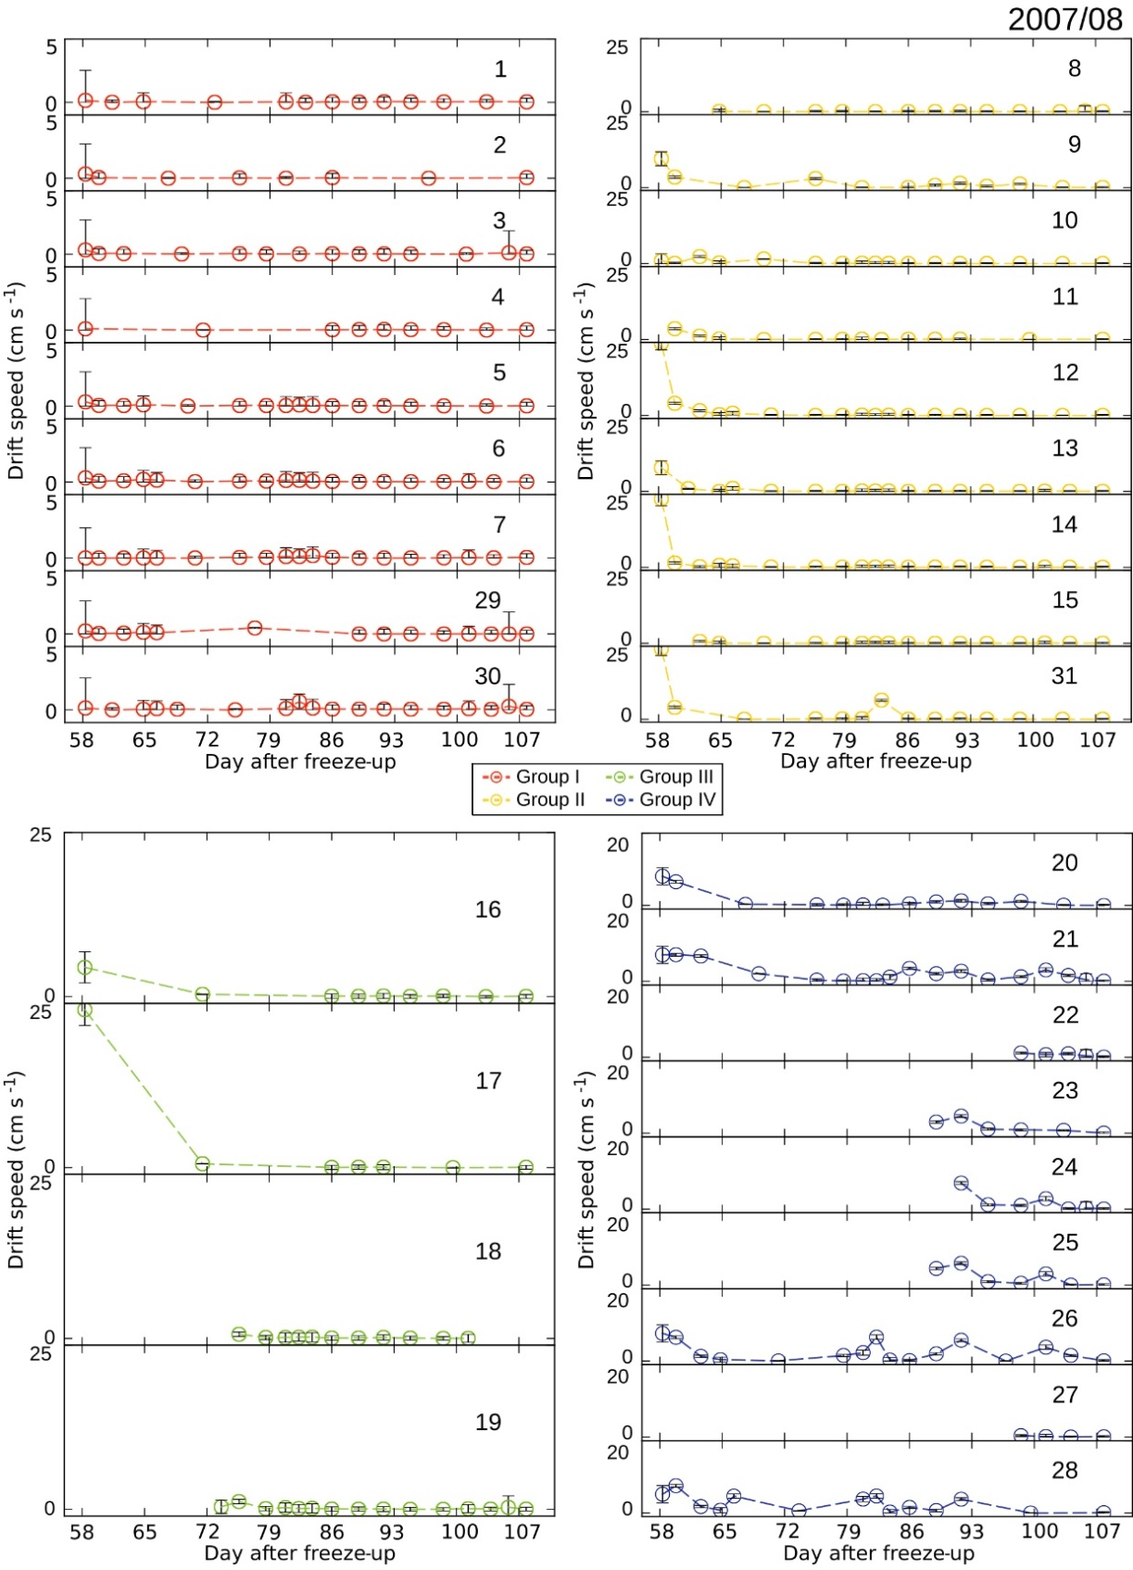
Supplementary material for: Selyuzhenok V., Mahoney A., Krumpen T., Castellani G. & Gerdes R. 2017. Mechanisms of fast-ice development in the south-eastern Laptev Sea: a case study for winter of 2007/08 and 2009/10. Polar Research 36. Contact: V. Selyuzhenok, Nansen International Environmental and Remote Sensing Centre, 14 liniya V.O. 7, St Petersburg, 199034, Russia. E-mail valeria.selyuzhenok@niersc.spb.ru
Supplementary Fig. S1. Time series of drift speed for all features of 2007/08. The error bars show range of drift for each time step. The number in the upper right corner refers to the feature’s number in Fig. 5a.
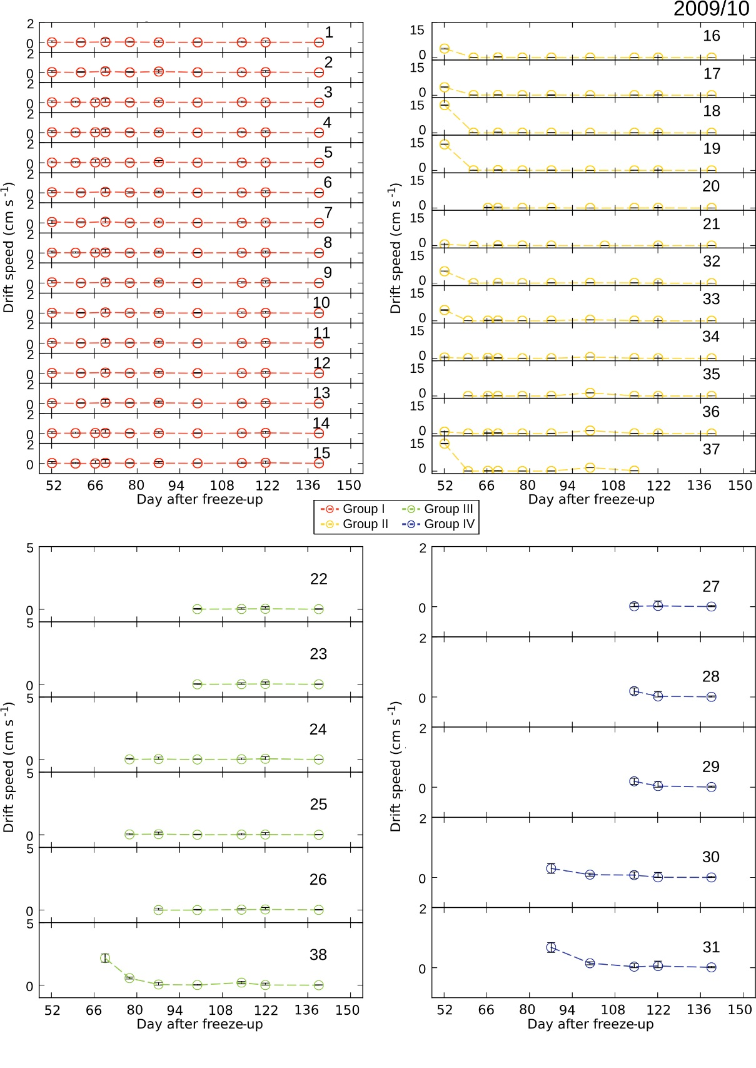
Supplementary Fig. S2. Time series of drift speed for all features of 2009/10. The error bars show range of drift for each time step. The number in the upper right corner refers to the feature’s number in Fig. 5a.

