Environmental influences on the at-sea behaviour of a major consumer, Mirounga leonina, in a rapidly changing environment.
Trevor McIntyre^{1,2}, Horst Bornemann¹, P. J. Nico de Bruyn², Ryan R. Reisinger², Daniel Steinhage¹, Maria E.I. Márquez³, Marthán N. Bester² and Joachim Plötz¹
1. Alfred Wegener Institut Helmholtz-Zentrum für Polar-und Meeresforschung, Postfach 120161, D-27515, Bremerhaven, Germany.
2. Mammal Research Institute, Department of Zoology and Entomology, University of Pretoria, Private Bag X20, Hatfield, 0028, South Africa.
3. Instituto Antártico Argentino, Depto. Biologia de Predadores Tope, Cerrito 1248, (C1010AAZ) Buenos Aires, Argentina.

Supplementary Material
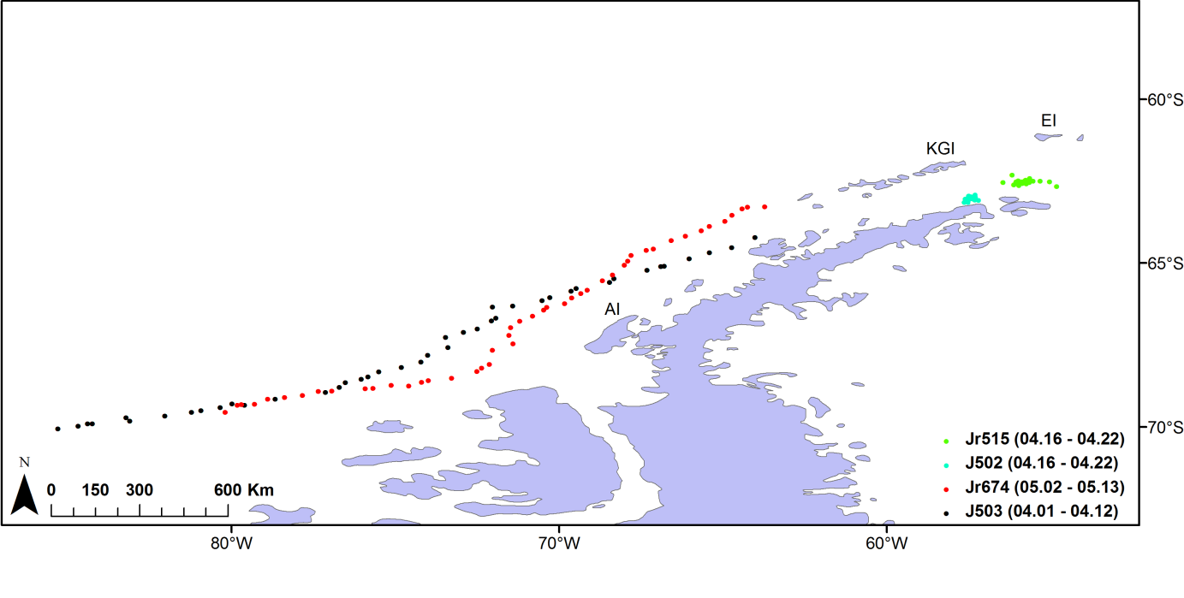
Figure S1: Spatial and temporal distribution of temperature profiles used for comparative purposes between refurbished CTD-SRDLs and new CTD-SRDLs. Note that the spatial locations of Jr515 (refurbished) do not overlap with J502 (new), but are in close proximity (within ~ 100 km) to one another, and were obtained over the same time period. The comparative profiles of Jr674 (refurbished) and J503 (new) were consistently within close proximity to each other (maximum of ~ 110 km, but mostly within ~ 60 km), and were obtained approximately 1 month apart.

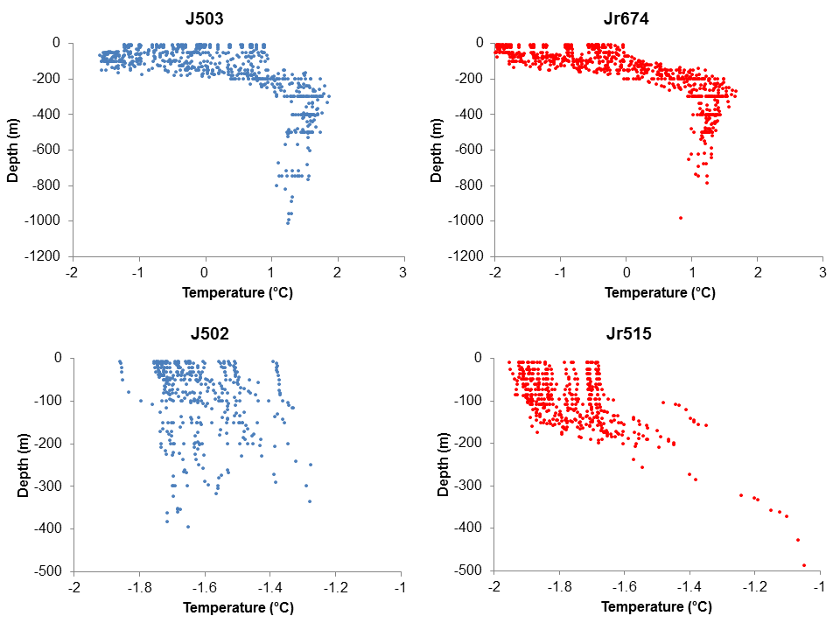
Figure S2: Temperature extracted for comparative purposes. Jr674 and Jr515 were refurbished CTD-SRDLs, while J503 and J502 were new CTD-SRDLs. Positions of profile locations and dates of measurement are displayed in Fig. S1.

Figure S3: Box- and whisker plots of sea ice concentration in areas utilised by seals in this study, divided by length (top plot), calculated weight (middle plot) and body condition residuals (bottom plot). Bold line = median, box = 25th and 75th percentiles, points = outliers, whiskers = 1.5 times the interquartile range, or the maximum values (when there are no outliers).

Figure S4: Box- and whisker plots of dive parameters (depth, duration, bottom time and percentage bottom time) in relation to body length, calculated weight and body condition residuals of tracked seals. Bold line = median, box = 25th and 75th percentiles, points = outliers, whiskers = 1.5 times the interquartile range, or the maximum values (when there are no outliers).

