Supplementary material for: Kulaszewicz I. & Jakubas D. Influence of nest burrow microclimate on chick growth in a colonial High-Arctic seabird, the little auk. Polar Research 37. Contact: University of Gdańsk, Department of Vertebrate Ecology and Zoology, Wita Stwosza 59, 80-308 Gdańsk, Poland. E-mail: bioik@univ.gda.pl

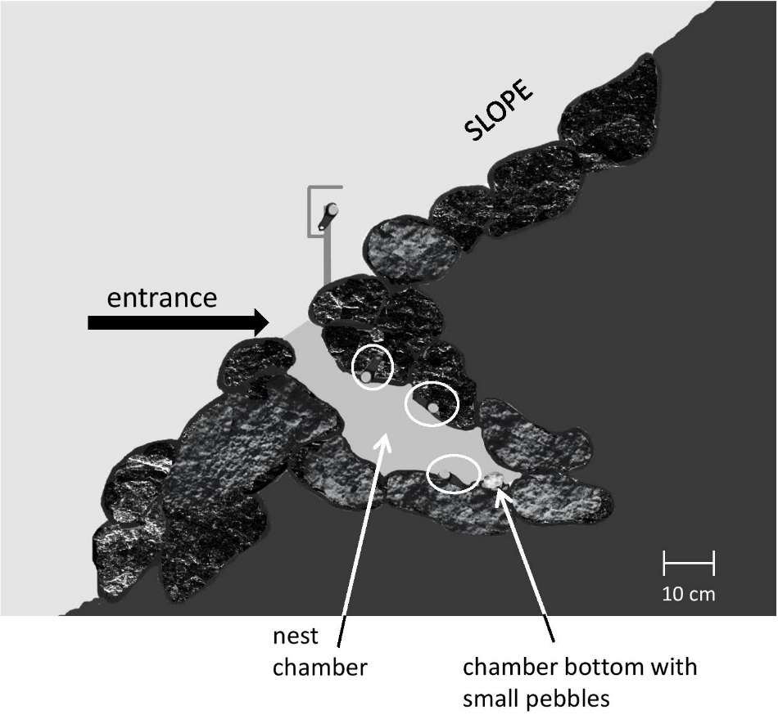
Supplementary Fig. 1. Location of three loggers inside nest chamber, shown in side view.

Supplementary Table S1. Nest temperature (mean ± SE, amplitude [maximum–minimum]) in particular in the three phases studied and mean amplitude differences (compared to highest temperature). The nest with the highest temperatures recorded is shown in boldface.
 |  | Nest temperature (°C)
 | Altitude  (m a.s.l.) | Chick-rearing phase 1 |  | Chick-rearing phase 2 |  | Post-breeding period
Nest ID |  | Mean ± SE | Amplitude (max–min) | Mean ± SE | Amplitude (max–min) | Mean ± SE | Amplitude (max–min)
N1 | 52 | 6.82 ± 0.051 | - 1.65 | 5.48 ± 0.056 | - 2.29 | 4.48 ± 0.043 | - 1.79
N2 | 61 | 8.22 ± 0.062 | - 0.25 | 7.11 ± 0.034 | - 0.66 | 4.82 ± 0.028 | - 1.45
N3 | 42 | 5.41 ± 0.045 | - 3.06 | 4.38 ± 0.021 | - 3.39 | 3.71 ± 0.042 | - 2.56
N4 | 46 | 5.51 ± 0.043 | - 2.96 | 4.49 ± 0.043 | - 3.28 | 3.96 ± 0.032 | - 2.31
N5 | 59 | 6.01 ± 0.031 | - 2.46 | 5.24 ± 0.065 | - 2.53 | 4.41 ± 0.008 | - 1.86
N6 | 62 | 7.28 ± 0.034 | - 1.19 | 5.78 ± 0.022 | - 1.99 | 5.01 ± 0.077 | - 1.26
N7 | 54 | 7.72 ± 0.054 | - 0.75 | 6.76 ± 0.037 | - 1.01 | 5.42 ± 0.040 | - 0.85
N8 | 74 | 8.47 ± 0.064 | 0.00 | 7.77 ± 0.034 | 0.00 | 6.27 ± 0.085 | 0.00
N9 | 64 | 8.08 ± 0.033 | - 0.39 | 6.78 ± 0.055 | - 0.99 | 4.88 ± 0.026 | - 1.39
N10 | 67 | 8.42 ± 0.063 | - 0.05 | 7.17 ± 0.065 | - 0.60 | 5.88 ± 0.052 | - 0.39
Inter-nest amplitude |  |  | - 1.28 ± 0.27 |  | - 1.67 ± 0.29 |  | - 1.39 ± 0.21

